Web Development Assignment #4 Report

# Media Queries + Bootstrap Grid

Team Information

 **Team Name:** Coffee PO Team

 **Group:** SE-2404

 **Team Members:** Balgyn, Ayana

 **Submission Date:** October 4, 2025

 **Deployed Website URL:** [Your GitHub Pages/Netlify URL here]

# Part 1: Media Queries

## Task 1: Responsive Typography

**Implementation:** Created responsive font sizes that change based on screen size.

**Code:**

/* Mobile (< 576px) */

.responsive-title { font-size: 1.75rem;

}

/* Tablet (≥ 768px) */

@media (min-width: 768px) {

.responsive-title { font-size: 2.5rem;

}

}

/* Desktop (≥ 992px) */

@media (min-width: 992px) {

.responsive-title { font-size: 3rem;

}

}

## Task 2: Card Group - Responsive Layout

**Implementation:** Three cards display side-by-side on desktop, 2 per row on tablet, stacked on mobile using CSS media queries only.

**Code:**

/* Mobile: Stack vertically */ @media (max-width: 767px) {

.card-responsive-group > div { flex: 0 0 100%;

max-width: 100%;

}

}

/* Tablet: Two per row */

@media (min-width: 768px) and (max-width: 991px) {

.card-responsive-group > div { flex: 0 0 50%;

max-width: 50%;

}

}

/* Desktop: Three per row */ @media (min-width: 992px) {

.card-responsive-group > div { flex: 0 0 33.333%;

max-width: 33.333%;

}

}

# Part 2: Bootstrap Integration

## Task 3: Bootstrap Grid Layout

**Implementation:** Used Bootstrap's grid system with 2-column and 3-column layouts.

**Code:**

<!-- Two Column Section -->

<div class="row g-4 mb-5">

<div class="col-lg-6 col-md-6 col-sm-12">

<div class="p-4 bg-white rounded shadow-sm h-100">

<h3 class="mb-3">Our Story</h3>

<p>Content...</p>

</div>

</div>

<div class="col-lg-6 col-md-6 col-sm-12">

<div class="p-4 bg-white rounded shadow-sm h-100">

<h3 class="mb-3">Our Mission</h3>

<p>Content...</p>

</div>

</div>

</div>

## Task 4: Bootstrap Spacing Utilities

**Implementation:** Replaced custom margins/paddings with Bootstrap spacing classes.

**Bootstrap Classes Used:**

 py-5 - Vertical padding  my-5 - Vertical margin  mb-4 - Bottom margin  g-4 - Grid gap

 p-4 - Padding all sides

 px-lg-4 - Responsive horizontal padding

**Example:**

<section class="container-fluid py-5 bg-light">

<div class="container my-5">

<div class="row g-4 mb-5"></div>

</div>

</section>

**Screenshots:**

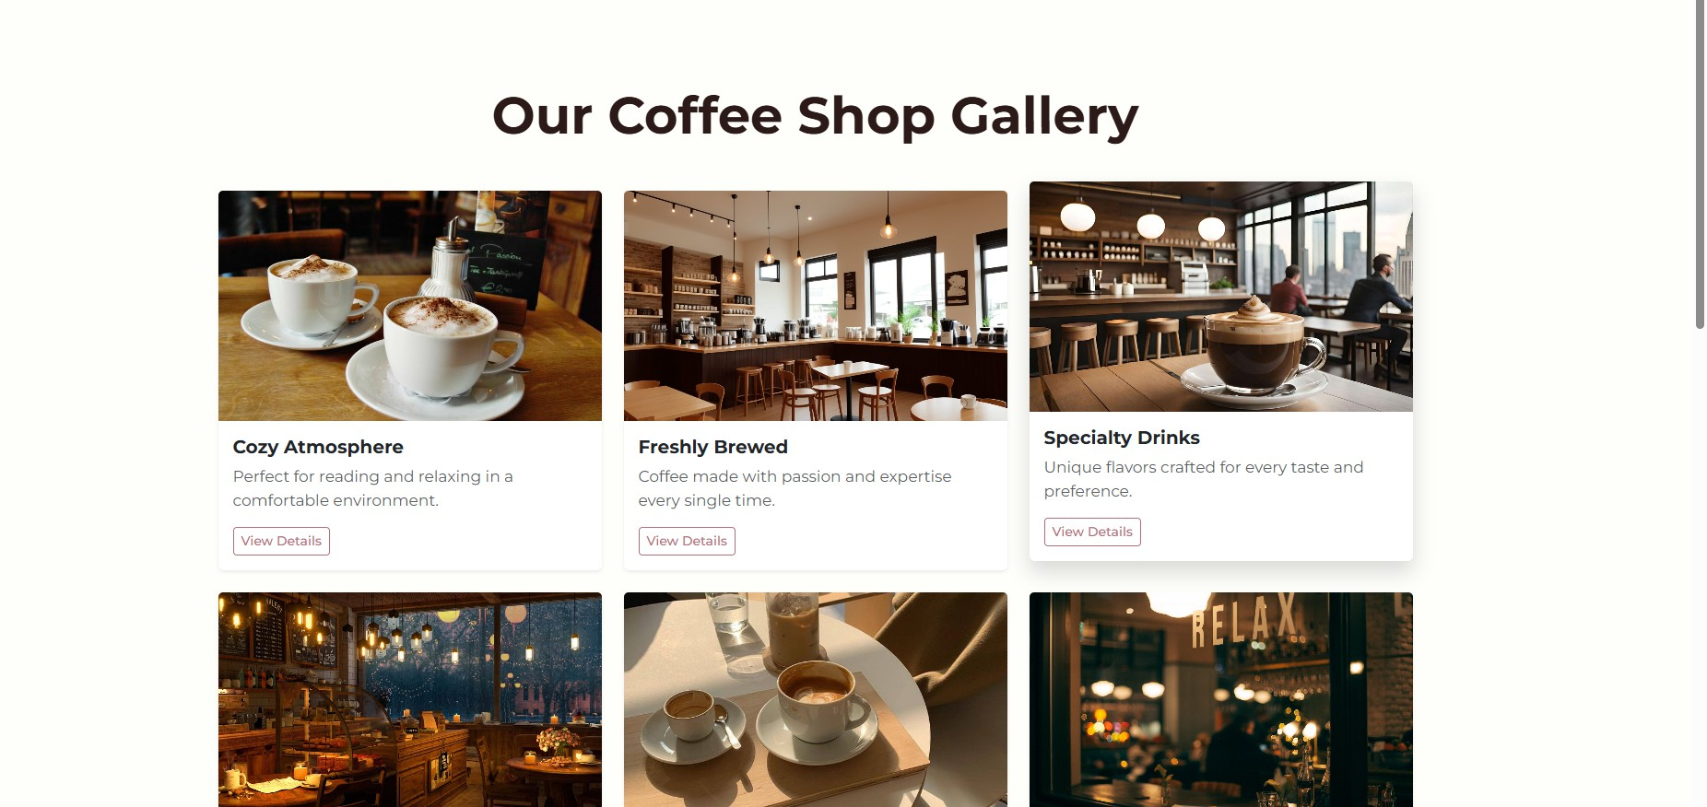

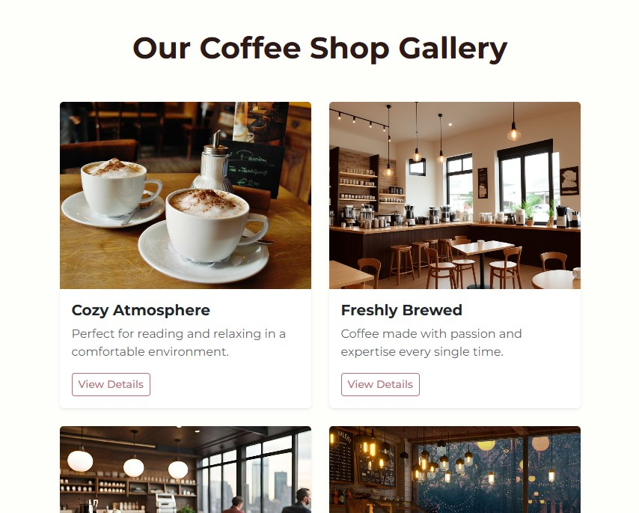

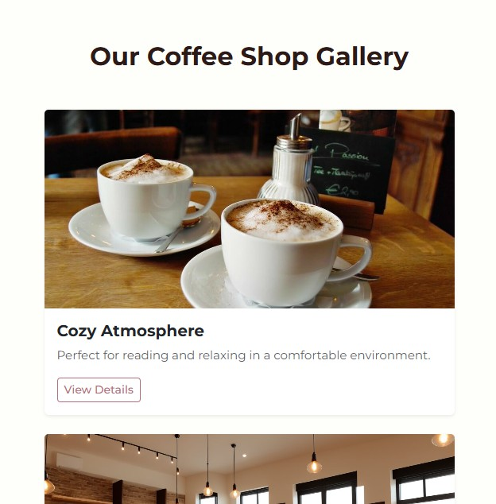

## Task 5: Bootstrap Navigation Bar

**Implementation:** Responsive navbar with hamburger menu for mobile devices.

**Code:**

<nav class="navbar navbar-expand-lg navbar-dark bg-dark sticky-top">

<div class="container-fluid px-lg-4 px-3">

<a class="navbar-brand fw-bold text-warning" href="index.html">Coffee PO</a>

<button

class="navbar-toggler" type="button"

data-bs-toggle="collapse"

data-bs-target="#navbarNav"

>

<span class="navbar-toggler-icon"></span>

</button>

<div class="collapse navbar-collapse" id="navbarNav">

<ul class="navbar-nav ms-auto">

<li class="nav-item">

<a class="nav-link active" href="index.html">Home</a>

</li>

<!-- More links... -->

</ul>

</div>

</div>

</nav>

**Screenshots:**

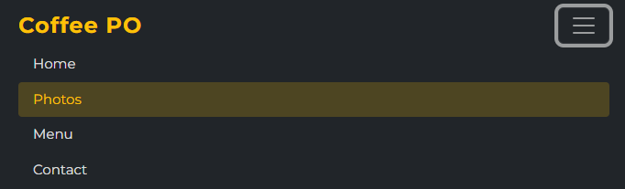

## Task 6: Bootstrap Buttons

**Implementation:** Replaced custom buttons with Bootstrap button classes and created button groups.

**Code:**

<!-- Primary Button -->

<a href="#" class="btn btn-primary mt-3">Learn More</a>

<!-- Outline Button -->

<a href="menu.html" class="btn btn-outline-primary mt-3">View Menu</a>

<!-- Button Group -->

<div class="btn-group btn-group-lg" role="group">

<a href="menu.html" class="btn btn-outline-dark">Our Menu</a>

<a href="gallery.html" class="btn btn-outline-dark">Gallery</a>

<a href="contact.html" class="btn btn-outline-dark">Contact Us</a>

</div>

**Screenshots:**

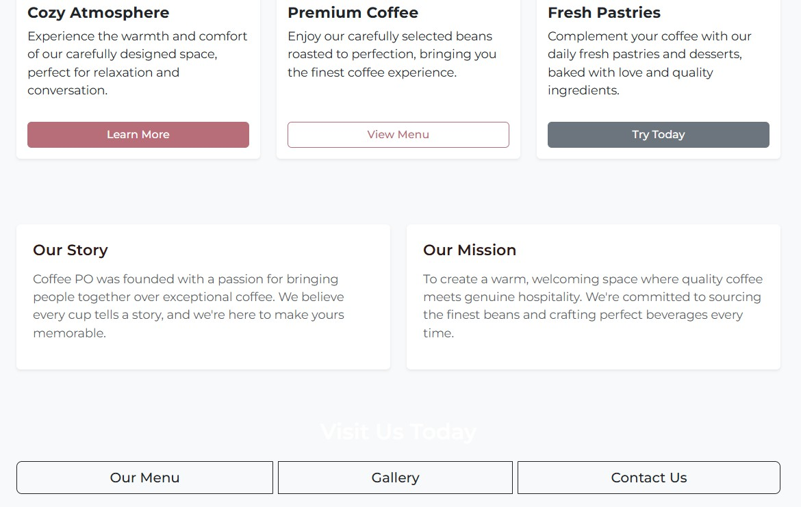

## Task 7: Bootstrap Carousel

**Implementation:** Added carousel with 9 images, navigation controls, and indicators on homepage.

**Code:**

<div id="heroCarousel" class="carousel slide" data-bs-ride="carousel">

<div class="carousel-indicators">

<button

type="button"

data-bs-target="#heroCarousel" data-bs-slide-to="0"

class="active"

></button>

<!-- 8 more indicators... -->

</div>

<div class="carousel-inner">

<div class="carousel-item active">

<img src="img/2.jpg" class="d-block w-100 carousel-img" alt="Coffee" />

<div class="carousel-caption d-none d-md-block">

<h1 class="display-3 fw-bold">coffee PO</h1>

</div>

</div>

<!-- 8 more items... -->

</div>

<button

class="carousel-control-prev" type="button"

data-bs-target="#heroCarousel" data-bs-slide="prev"

>

<span class="carousel-control-prev-icon"></span>

</button>

<button

class="carousel-control-next" type="button"

data-bs-target="#heroCarousel" data-bs-slide="next"

>

<span class="carousel-control-next-icon"></span>

</button>

</div>

**CSS for Responsive Height:**

.carousel-img { height: 600px;

object-fit: cover;

}

@media (max-width: 768px) {

.carousel-img { height: 400px;

}

}

@media (max-width: 576px) {

.carousel-img { height: 300px;

}

}

**Screenshots:**

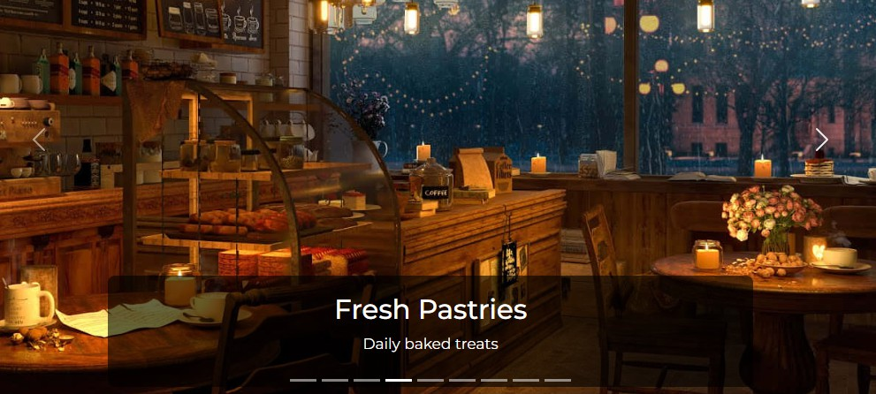

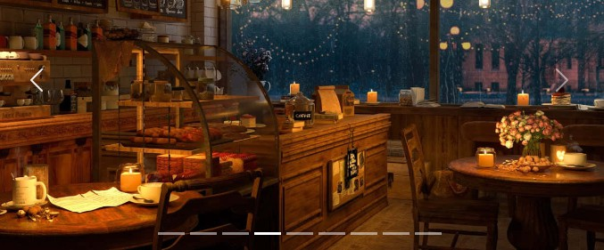

## Task 8: Bootstrap Cards

**Implementation:** Replaced custom content boxes with Bootstrap cards on all pages.

**Code:**

<div class="col-lg-4 col-md-6 col-sm-12">

<div class="card h-100 shadow-sm border-0">

<img src="img/1.jpeg" class="card-img-top" alt="Cozy Atmosphere" />

<div class="card-body d-flex flex-column">

<h3 class="card-title fw-bold">Cozy Atmosphere</h3>

<p class="card-text flex-grow-1">Experience the warmth...</p>

<a href="#" class="btn btn-primary mt-3">Learn More</a>

</div>

</div>

</div>

**Pages with Cards:**

 index.html: 3 feature cards  gallery.html: 9 photo cards  menu.html: 5 menu cards

## Task 9: Responsive Form Design

**Implementation:** Replaced custom form styling with Bootstrap form classes on contact page.

**Code:**

<form>

<!-- Text Input -->

<div class="mb-4">

<label for="name" class="form-label fw-semibold">Your Name</label>

<input

type="text"

class="form-control form-control-lg" id="name"

placeholder="Enter your full name" required

/>

</div>

<!-- Email with Input Group -->

<div class="mb-4">

<label for="email" class="form-label fw-semibold">Your Email</label>

<div class="input-group input-group-lg">

<span class="input-group-text">@</span>

<input type="email" class="form-control" id="email" required />

</div>

<div class="form-text">We'll never share your email.</div>

</div>

<!-- Select Dropdown -->

<div class="mb-4">

<label for="subject" class="form-label fw-semibold">Subject</label>

<select class="form-select form-select-lg" id="subject">

<option>Choose a subject...</option>

<option>General Inquiry</option>

<option>Reservation</option>

</select>

</div>

<!-- Checkbox -->

<div class="form-check">

<input class="form-check-input" type="checkbox" id="newsletter" />

<label class="form-check-label" for="newsletter"> Subscribe to our newsletter

</label>

</div>

<!-- Radio Buttons -->

<div class="form-check">

<input

class="form-check-input" type="radio"

name="contact"

id="contactEmail" checked

/>

<label class="form-check-label" for="contactEmail">Email</label>

</div>

<!-- Submit Button -->

<button type="submit" class="btn btn-primary btn-lg">Send Message</button>

</form>

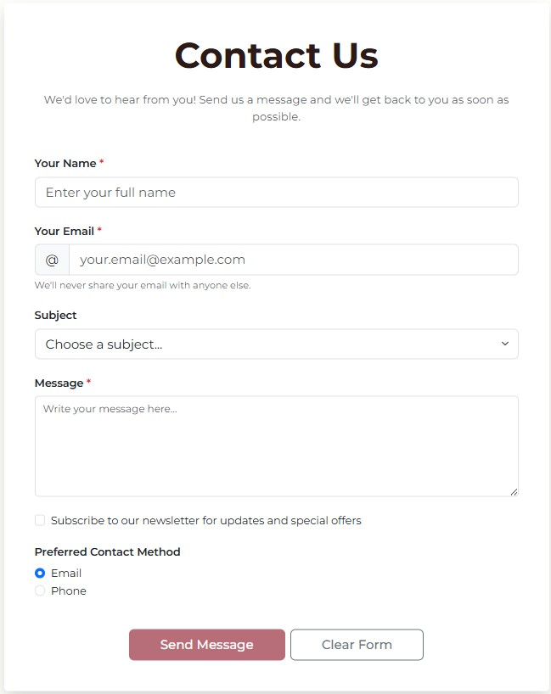**Screenshots:**

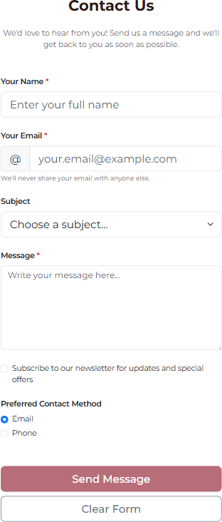

## Task 10: Accessibility

**Implementation:** Used semantic HTML and ARIA labels for better accessibility.

**Code Examples:**

<!-- Semantic Navigation -->

<nav class="navbar navbar-expand-lg">

<ul class="navbar-nav">

<li class="nav-item">

<a class="nav-link active" aria-current="page" href="index.html">Home</a>

</li>

</ul>

</nav>

<!-- ARIA Labels -->

<button class="navbar-toggler" aria-label="Toggle navigation">

<span class="navbar-toggler-icon"></span>

</button>

<a href="#" class="btn btn-outline-light" aria-label="Visit our Facebook page"> Facebook

</a>

<!-- Form Labels -->

<label for="email" class="form-label">Your Email</label>

<input type="email" class="form-control" id="email" />

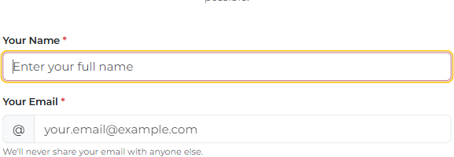**Screenshots:**

# Conclusion

Successfully completed Assignment #4 by integrating Bootstrap framework into the existing Coffee PO

website. All 10 tasks were implemented with proper responsive design, accessibility features, and clean code structure.

**Prepared By:** Balgyn & Ayana

**Date:** October 4, 2025

**Course:** Web Development, SE-2404

*End of Report*